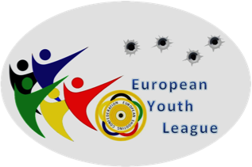

European Shooting Confederation

European Youth League – EYL

Registration Form – Please return by 31st of December 2014 at the latest

We will take part in the Rifle competition | YES/NO (choose one alternative)
We will take part in the Pistol competition | YES/NO (choose one alternative)

Name of Federation
IOC – Code
Contact person
Phone number
Fax number
E-mail address

Please choose your Regional Group and send this form to the Regional Group Manager:

East – Goran Martinovic / CRO, goran.martinovic2@pu.t-com.hr
North – Kerstin Bodin / SWE, kerstin.bodin@telia.com
West – Ghislaine Briez / FRA, gbriez@fftir.org

 | EAST |  | NORTH |  | WEST
 | ALB | Albania | DEN | Denmark | AND | Andorra
 | ARM | Armenia | EST | Estonia | AUT | Austria
 | AZE | Azerbaijan | FIN | Finland | BEL | Belgium
 | BIH | Bosnia and Herzegovina | GBR | Great Britain | CZE | Czech Republic
 | BLR | Belarus | IRL | Ireland | ESP | Spain
 | BUL | Bulgaria | ISL | Iceland | FRA | France
 | CRO | Croatia | LAT | Latvia | GER | Germany
 | CYP | Cyprus | LTU | Lithuania | HUN | Hungary
 | GEO | Georgia | NOR | Norway | ITA | Italy
 | GRE | Greece | POL | Poland | LIE | Liechtenstein
 | ISR | Israel | SWE | Sweden | LUX | Luxembourg
 | MDA | Republic of Moldova |  |  | MLT | Malta
 | MKD | F. Y. R. of Macedonia |  |  | MON | Monaco
 | MNE | Republic of Montenegro |  |  | NED | Netherlands
 | ROU | Romania |  |  | POR | Portugal
 | RUS | Russian Federation |  |  | SLO | Slovenia
 | SRB | Republic of Serbia |  |  | SVK | Slovakia
 | TUR | Turkey |  |  | SMR | San Marino
 | UKR | Ukraine |  |  | SUI | Switzerland

