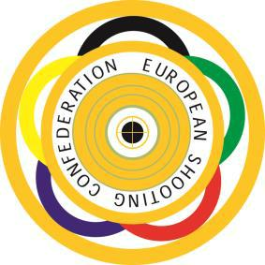
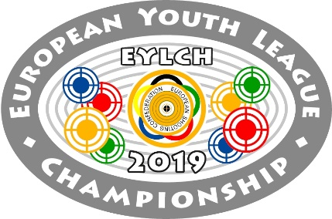
EUROPEAN YOUTH LEAGUE
CHAMPIONSHIP

BUDAPEST – HUNGARY

2nd – 6th October 2019

LUNCH BOX FORM

Daily lunch boxes will be served at the shooting range upon previous demand

for 15€/box. The following quantity of boxes will be requested by the Shooting

Federation of ……………………..

Day | Number of boxes | €
October 3rd/ Thursday

October 4th / Friday
October 5th/Saturday

TOTAL:

This form is to be sent back to the Organizing Committee until September 15, 2019 and payment should also be effected with the same deadline.

