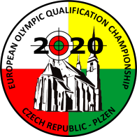EUROPEAN OLYMPIC QUALIFICATION CHAMPIONSHIP
Rifle, Pistol
Plzen Czech Republic
18 MAY – 25 MAY 2020

Please email to Travel Agency at: Mail hazukovo@gmail.com

ANNEX 2

PRELIMINARY HOTEL FORM |  | Please return by |  |  | 18 FEB 2020
Name of federation |  |  | Nation  (3 letter code)
Contact person |  |  | Phone number
E-mail address |  |  | Fax number

Hotel  Choice | No | Please indicate the Hotel Category in order of preference
 | 1
 | 2

Room choice | Room type | Number of rooms | Number of nights
 | single
 | double/twin

Date Signature of Team Leader

Organizing Committee
Czech Shooting Federation
U Pergamenky 1511/3
170 00 PRAGUE
Czech Republic
Phone : +420 220 87 67 97
Fax : +420 220 87 67 97
E-mail: info@eoqch2020.eu

