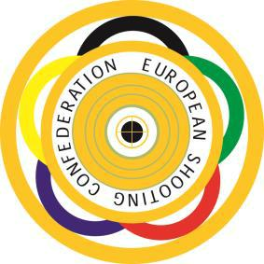
EUROPEAN YOUTH LEAGUE
CHAMPIONSHIP

BUDAPEST – HUNGARY

29th September – 2nd October 2022

ATHLETES’ REGISTRATION LIST

Country: ……………………………………..

No. | Surname | Name | Date of birth | Gender (M/F) | Rifle/Pistol

This form is to be sent back to the Organizing Committee
until September 2, 2022

