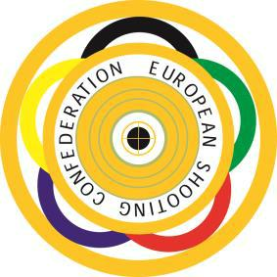
EUROPEAN YOUTH LEAGUE
CHAMPIONSHIP

BUDAPEST – HUNGARY

29th September – 2nd October 2022

LUNCH BOX FORM

Daily lunch boxes will be served at the shooting range upon previous demand

for 20€/box. The following quantity of boxes will be requested by the Shooting

Federation of

Day | Number of boxes | €
September 29th/ Thursday

September 30th/ Friday
October 1st/Saturday

TOTAL:

This form is to be sent back to the Organizing Committee until September 2, 2022 and payment should also be effected with the same deadline.

