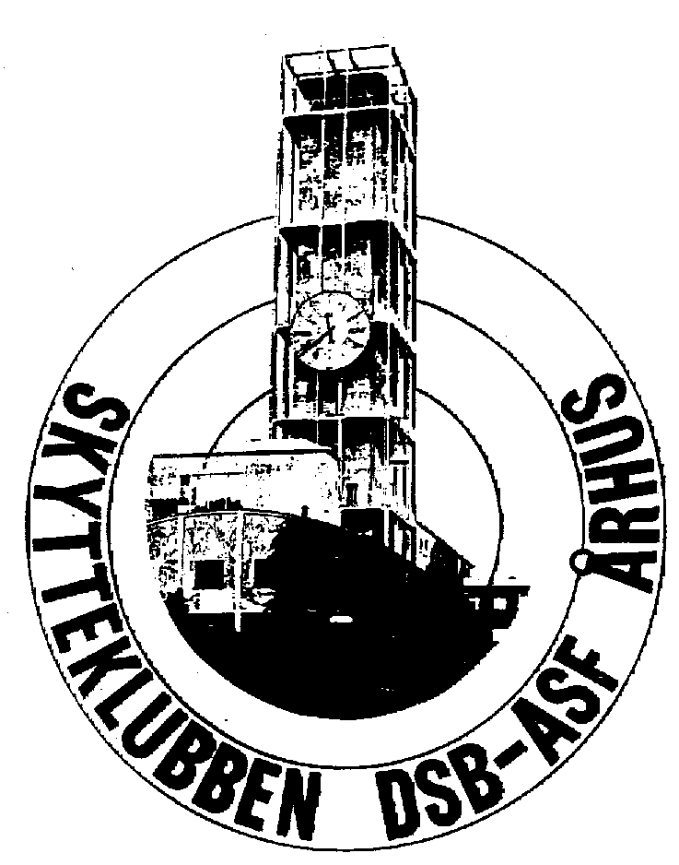
M A S T E R S
in Aarhus Danmark
15th of June to 18th of June 2023
International Rifle Competition
Please fill in names and shooting times
Only one start pr. Day in all disciplines

