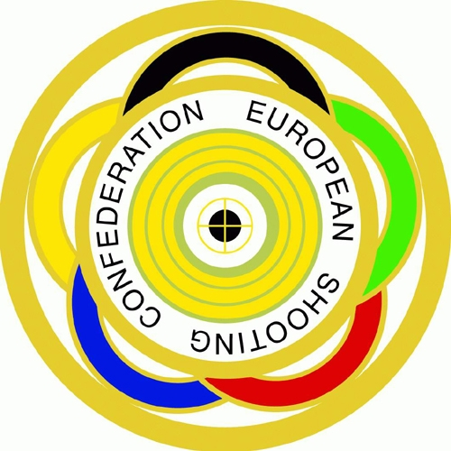

###### European Shooting Confederation

**European Youth League Championship – EYLCH**

**Registration Form – Please return by 31st of December 2022 at the latest**

|  |  |
| --- | --- |
| We will take part in the Rifle competition | **YES/NO** (choose one alternative) |
| We will take part in the Pistol competition | **YES/NO** (choose one alternative) |

|  |  |
| --- | --- |
| Name of Federation |  |
| IOC – Code |  |
| Contact person |  |
| Phone number |  |
| Fax number |  |
| E-mail address |  |

Please choose your Regional Group and send this form to the Regional Group Manager:

East – Goran Martinovic / CRO, [goran.martinovic2@pu.t-com.hr](mailto:goran.martinovic2@pu.t-com.hr)

North – Lars Erik Bjuhr /SWE, le.bjuhr@telia.com

West – Ghislaine Briez / FRA, [gy.briez@orange](mailto:gy.briez@orange).fr

|  |  |  |  |  |  |  |
| --- | --- | --- | --- | --- | --- | --- |
|  | **EAST** |  | **NORTH** |  | **WEST** |  |
| **ALB** | Albania | **DEN** | Denmark | **AND** | Andorra |
| **ARM** | Armenia | **EST** | Estonia | **AUT** | Austria |
| **AZE** | Azerbaijan | **FIN** | Finland | **BEL** | Belgium |
| **BIH** | Bosnia and Herzegovina | **GBR** | Great Britain | **CZE** | Czech Republic |
| **BLR** | Belarus | **IRL** | Ireland | **ESP** | Spain |
| **BUL** | Bulgaria | **ISL** | Iceland | **FRA** | France |
| **CRO** | Croatia | **LAT** | Latvia | **GER** | Germany |
| **CYP** | Cyprus | **LTU** | Lithuania | **HUN** | Hungary |
| **GEO** | Georgia | **NOR** | Norway | **ITA** | Italy |
| **GRE** | Greece | **SWE** | Sweden | **LIE** | Liechtenstein |
| **ISR** | Israel |  |  | **LUX** | Luxembourg |
| **MDA** | Republic of Moldova |  |  | **MLT** | Malta |
| **MKD** | F. Y. R. of Macedonia |  |  | **MON** | Monaco |
| **POL** | Poland |  |  | **NED** | Netherlands |
| **ROU** | Romania |  |  | **POR** | Portugal |
| **RUS** | Russian Federation |  |  | **SLO** | Slovenia |
| **SRB** | Republic of Serbia |  |  | **SVK** | Slovakia |
| **TUR** | Turkey |  |  | **SMR** | San Marino |
| **UKR** | Ukraine |  |  | **SUI** | Switzerland |