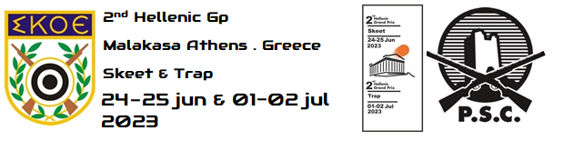
Please e-mail to: psachnashootingclub@gmail.com

VISA SUPPORT FORM |  |  |  |  | Please return by |  |  |  | 24 May 2023
name of federation |  |  |  |  | nation
contact person |  |  |  |  | phone number
e-mail address |  |  |  |  | fax number
no | family name |  | first name | date of birth |  | passport number |  | issue on |  | issue by

ORGANIZING COMMITTEE
Hellenic Shooting Federation
Xr. Vournazou 14. – 115 21 Athens - Greece
Phone: +30 21 0645 4522
Fax: +30 21 0645 4522
E-mail: info@skoe.gr
Web: www.skoe.gr

