
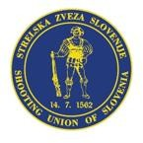
LAPUA EUROPEAN CUP
25 m PISTOL
12. 6. - 14. 6. 2026

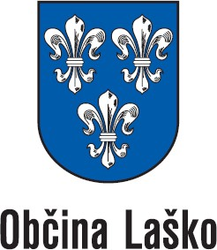
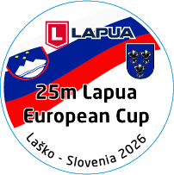
Laško / Slovenia

PRELIMINARY ENTRY FORM
Country Contact person

E-mail

Phone

Address

Participants

 | Male | Female | Center Fire Pistol | Standard Pistol | Pistol Mixed Team
Number of athletes
Number of officials

Banquette evening in hotel Thermana Laško

Saturday evening
3-course menu and 2 dcl of wine or draft beer (35 € p.P.)
Number of participants
comment

Transportation

We arrive by... (x) | Airplane | Train | Bus | Car

Arrival by Flight at day and time |  | Flight- No. |  | Number of people
Departure by Flight at day and time |  | Flight- No. |  | Number of people

Date | Signature

Please send this “Preliminary Entry Form” NOT LATER THAN 25th May 2026 to the following E-mail address: andrej.brunsek@gmail.com

