

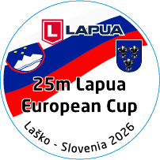
LAPUA
EUROPEAN CUP 25m
12. 6. - 14. 6. 2026
Laško / Slovenia


FINAL ENTRY FORM
Country Officials

Please send this “Final Entry Form” NOT LATER THAN 25th May 2026 to the following E-mail address: andrej.brunsek@gmail.com

 | Family name | Given name | ISSF ID | Passport number | Men = M Woman=W | Centre fire Pistol (x) | Standard Pistol (x) | Pistol Mixed Pairs (x) | Banguette (x) | Transfer (x)
Athlete 1
Athlete 2
Athlete 3
Athlete 4
Athlete 5
Athlete 6
Athlete 7
Athlete 8
Official
Official

